Pyramid (java) Project pictures

Total images: 03

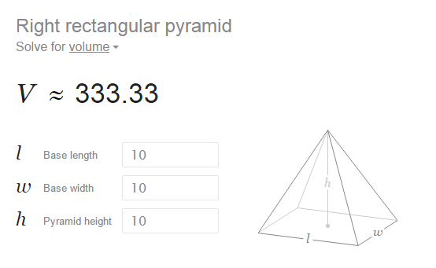

Fig 1: Volume of pyramid on google

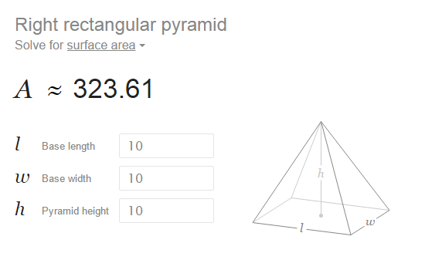

Fig 2: Surface area of pyramid on google

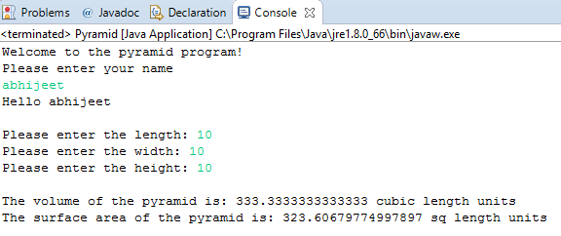

Fig 3: Our program, Surface area and Volume of pyramid